Cairo University
Faculty of Computers and Information
CS251 Software Engineering I
Course Project
2013
Project Plan

REVERSI
Team Name
CS_Gamers

ID | Name | Email | Dept/Grp | Mobile
20110281 | Mohamed Ahmed abd-algawad | Abdelgawad22@yahoo.com | CS_3 | 01112663844
20110335 | Mohamed Waleed Mohamed | max_max2394@yahoo.com | CS_3 | 01111533876
20110277 | Mohamed Ibrahim Mohamed | mibrahim070@gmail.com | CS_3 | 01117558353
20110432 | Ahmed Nasser Saleh | Ahmednasser1993@gmail.com | CS_4 | 01060185459

Table of Content
Table of Content 2
1. Project Overview 3
1.1. Project scope 3
1.1.1 Component one …… 3
1.1.2 Component two. … 3
1.2. Project Iterations and Deliverables 3
2. Management Structure 4
2.1. Project Lifecycle 4
2.2. Project Organization 4
2.2.1 Internal Structure 4
2.2.2 Roles and Responsibility 4
2.3. Risk Management 4
2.3.1 Top Risks List 4
2.3.2 Risk Mitigation Strategy: 4
3. Planning and Control 5
3.1. Work Breakdown 5
3.2. Tracking and control 5
3.2.1 Schedule 5
3.2.2 Milestones 5
3.2.3 Meetings and Reporting 5
3.3. Project Artifacts 5
4. Technical Process 6
4.1. Methodology, Models and Techniques 6
4.2. Technology 6
4.2.1 Environment 6
4.2.2 Development Tools 6

Project Overview
The project is a client server Reversi game. Users can play the game on Android platform.
Reversi is a strategy board game for two players, played on an 8×8 un-checkered board. There are 64 identical game pieces called disks, which are light on one side and dark on the other. Players take turns placing discs on the board with their assigned color facing up.
We will use the scrum methodology to produce our project

Project scope

Create a database that contains all data of the users and the state of the game.

Build the game and connect it with the database.

Project Iterations and Deliverables

Sprint 1  25 Oct. - 20 Nov. 2013 | Sprint 2  25 Nov. - 20 Dec. 2013
Software requirement specification and project plan | A source code  of demo version of Reversi game

Management Structure

Project Lifecycle
The functionality is prioritized at project inception and time-boxed releases are delivered, at which point additional functionality is incorporated to the code base. Upon each consecutive release, prior development activities may be revisited as necessary to address priority shift and requirements volatility.

Project Organization

Internal Structure

Each team member has the responsibility to complete a part of the source code and other members have to review his source code and merging the codes with each others

Roles and Responsibility
Role | Responsibility | Team Member
Scrum Master | Managing the scrum methodology | Mohamed ahmed Abd-algawad
Server management | Creates the database on the server and do the operation related to database | Mohamed Waleed
Development | Develop the necessary functions to manage the game intelligence | Mohamed Ibrahim
Building GUI | Building the user interface of the game | Ahmed Naser

Risk Management

Top Risks List

Risk | Probability | Impact | Exposure
Android knowledge | Medium | Low | Some Bugs
deliverable time | Medium | Medium | Less features

Risk Mitigation Strategy:
- About the Android knowledge we are learning the Android form good tutorials and learn from each other.
- Team leader decided that we will work hard to accomplish our goal in the exact time and increasing the work hours of the day.

Planning and Control

Work Breakdown
Server and database both plays an important role in developing the game because it the responsible for updating the state of the game in each player

Tracking and control
Try to improve the performance of the game and decrease its size on the disk and add more features.

Schedule

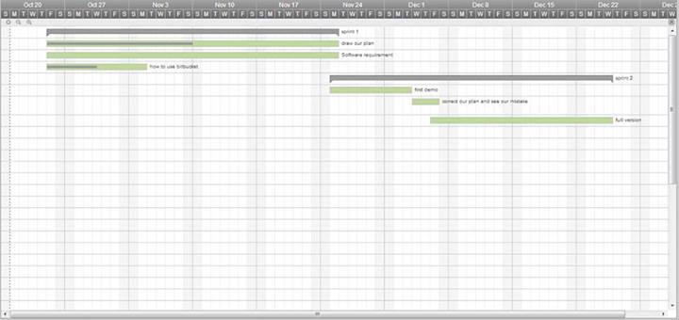
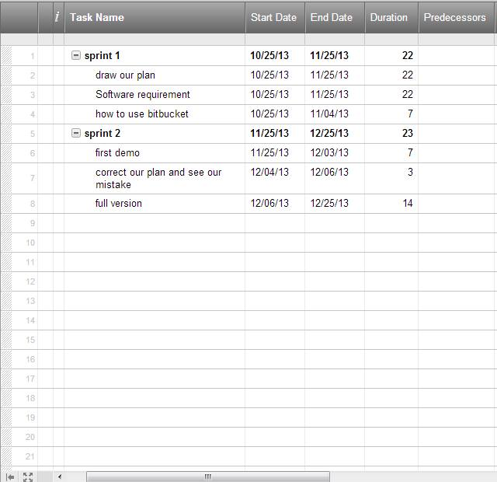

Milestones
Sprint 1: Software requirement specification and project plan that will take 25
Day
Sprint 2: A source code of demo version of Reversi game that will take 25
Day

Meetings and Reporting

Team members will meet together 3 days per week for 2 or 3 hours for discussing each part of each member and see the latest updates

Project Artifacts

Document Name | Description
Project Plan | A document containing the following subsections:  - Project Scope  - Management Structure  - Planning and Control  - Technical Process
SRS | A document containing the following subsections:  - Overview of the project  - objectives  - fundamental requirements
User Stories | Describes the demands of user in shorten way
Latest version of the game | Contain the final game with full features

Technical Process

Methodology, Models and Techniques
Using scrum and Git technology to manage the project files

Technology

Environment
Using Android API 2.3.3 (ginger bread as minimum SDK) for mobile phones

Development Tools
Java, Android API, SQLite, Android SDK, Eclipse IDE for Java

